The goal of this page is to support instructors to facilitate further interaction and thus move to a student-centered approach during class. Studies indicate that interactive (dialogic and authoritative) discourse moves enhance student engagement, facilitate critical thinking, and share the power dynamic between the instructor and students (Alkhouri et. Al 2021).
Figure 1 illustrates three different discourse moves. We emphasized the dialogic, interactive move since it can increase student-instructor and student-student interactions (Smith et al. 2013, Smith et al. 2014, Stains et al. 2018, Warfa et al. 2018). The two examples below and complementary figures exemplify common active learning activities to introduce and encourage interactive discourse into your lecture.
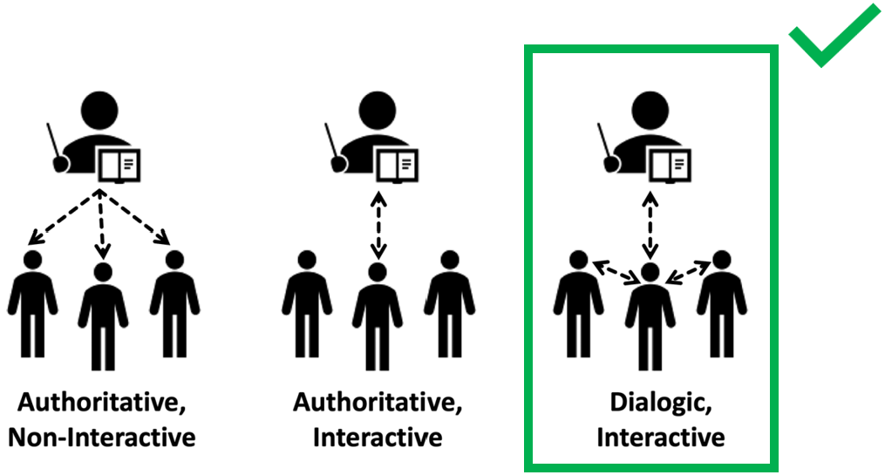
Figure 1. Adapted from Kranzfelder et al., 2019

1) How do I, as an instructor, encourage student interaction in my discourse?
Consider the dialogue below between a biology instructor and their student discussing the line graph below (Figure 2).
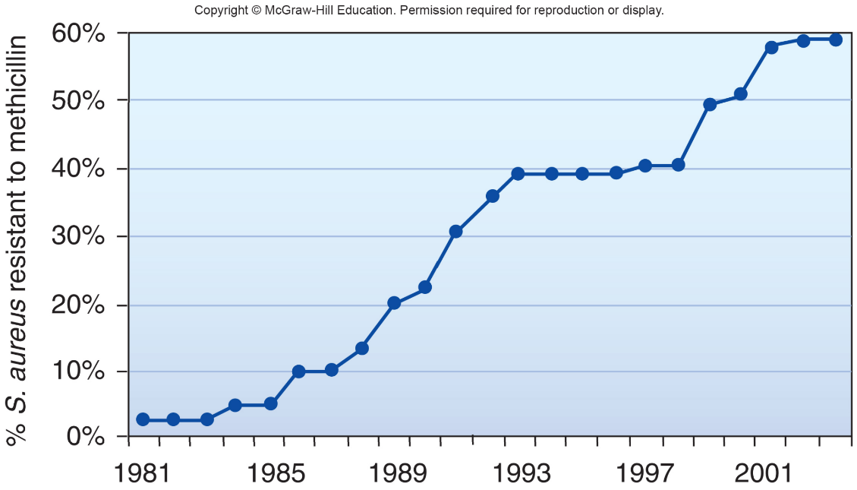
Instructor: “The bacterium Staphylococcus aureus causes skin infections commonly called staph infections. One antibiotic that has been used to treat staph infections is methicillin. However, resistance to this antibiotic has become a widespread problem. So, is evolution occurring?”.
Student: “Yes, evolution is occurring”.

The instructor can open the discussion further by implementing interactive statements as illustrated in Figure 3 to provide greater thinking opportunities and enhance student-engagement interactions (Smith et al. 2013, Smith et al. 2014, Stains et al. 2018, Warfa et al. 2018).
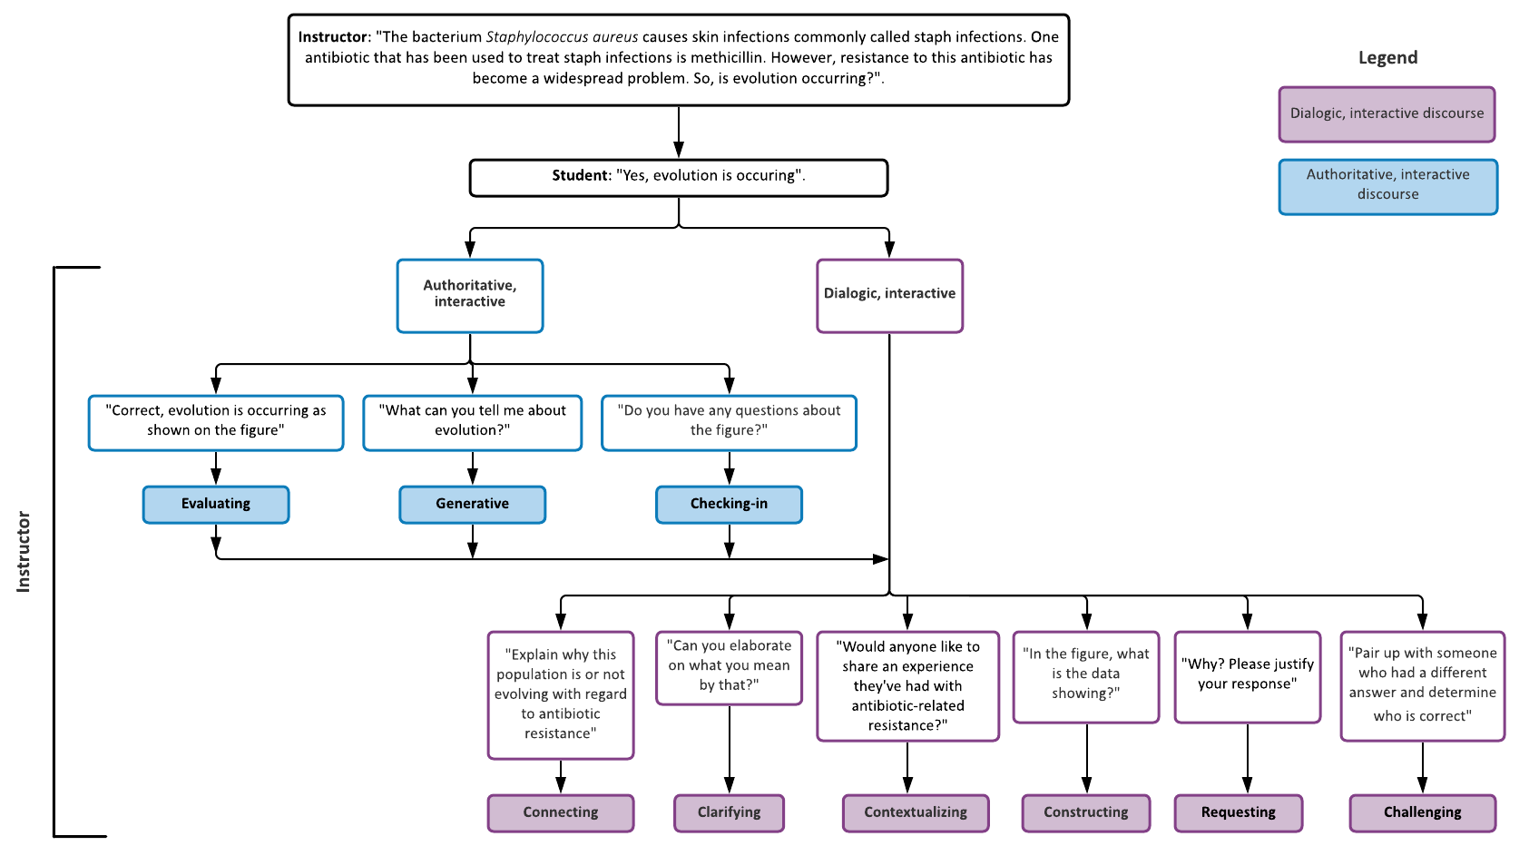
Figure 2. % S. aureus resistant to methicillin from McGraw-Hill Education
Figure 3

The flowchart in Figure 3 provides examples of how the instructor can further develop a student conversation. You can facilitate student-student interactions by having students participate in connecting, contextualizing, constructing, requesting, or challenging, dialogic interactive discourse moves. Student centered approaches encourage engagement and collaboration (Alkhouri et al. 2021).

2) How do I introduce interactive discourse while lecturing?
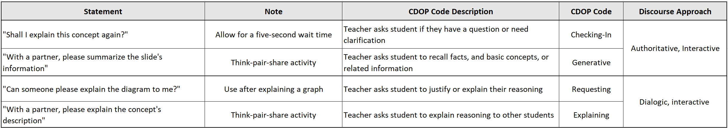
The following statements below assess student understanding periodically throughout your class time. Please remember to provide wait time after posing a question. The examples in Table 1 showcase how to disperse interactive discourse, and thus balance lecturing (or sharing) with student interaction throughout a class session. Click here for more literature regarding the importance of wait time, as described by Patricia E. Blosser.
Table 1

References
Blosser, Patricia E.. How to Ask the Right Questions. United States, National Science Teachers Association, 1991.

Jourjina Subih Alkhouri, Cristine Donham, Téa S Pusey, Adriana Signorini, Alexander H Stivers, Petra Kranzfelder, Look Who's Talking: Teaching and Discourse Practices across Discipline, Position, Experience, and Class Size in STEM College Classrooms, BioScience, Volume 71, Issue 10, October 2021, Pages 1063–1078, https://doi.org/10.1093/biosci/biab077

Kranzfelder P, Bankers-Fulbright JL, García-Ojeda ME, Melloy M, Mohammed S, Warfa A-RM (2019) The Classroom Discourse Observation Protocol (CDOP): A quantitative method for characterizing teacher discourse moves in undergraduate STEM learning environments.PLoS ONE 14(7): e0219019. https://doi.org/10.1371/journal.pone.021901

Petra Kranzfelder, Jennifer L Bankers-Fulbright, Marcos E García-Ojeda, Marin Melloy, Sagal Mohammed, Abdi-Rizak M Warfa, Undergraduate Biology Instructors Still Use Mostly Teacher-Centered Discourse Even When Teaching with Active Learning Strategies, BioScience, Volume 70, Issue 10, October 2020, Pages 901–913, https://doi.org/10.1093/biosci/biaa077

Scott P., Mortimer E. (2005) Meaning Making in High School Science Classrooms: A Framework for Analysing Meaning Making Interactions. In: Boersma K., Goedhart M., de Jong O., Eijkelhof H. (eds) Research and the Quality of Science Education. Springer, Dordrecht. https://doi.org/10.1007/1-4020-3673-6_31

Smith MK, Jones FHM, Gilbert SL, Wieman CE. 2013. The classroom observation protocol for undergraduate stem (COPUS): A new instrument to characterize university STEM classroom practices. CBE: Life Sciences Education 12: 618–627.

Smith MK, Vinson EL, Smith JA, Lewin JD, Stetzer MR. 2014. A campus wide study of stem courses: New perspectives on teaching practices and perceptions. CBE: Life Sciences Education 13: 624–635.

Stains M, et al. 2018. Anatomy of STEM teaching in North American universities. Science 359: 1468–1470. doi: 10.1126/science.aap8892.

Warfa A-RM, Nyachwaya J, Roehrig G. 2018. The influences of group dialog on individual student understanding of science concepts. International journal of STEM education 5: 46

This CDOP resource page is the collaborative effort between Avreen Bal, Isabella Woodruff, Matthew Phillip Guzman, Kim Ta, Riley Whitmer, Andrea Alvarez Gallardo, Adriana Signorini, and Petra Kranzfelder.

