The handout demonstrates ways instructors can implement more active-learning practices to their teaching based on their COPUS results. As illustrated in the table below, there are 12 individual instructor COPUS codes (Smith et al., 2013) that can be collapsed into four categories: Presenting, Guiding, Administering, and Other (Smith et al., 2014). There are 13 individual student COPUS codes, which can also be collapsed into four categories: Receiving, Working and Talking, Assessment, and Other (Kranzfelder et al., 2019). The Guiding and Working and Talking categories in green best represent student-centered practices; and hence represent optimal codes which facilitate student engagement and learning (Alkhouri et al., 2021). Based on our experience as observers, we paired each instructor code with one or more of the student codes to guide the implementation of more active-learning practices.
Instructor Collapsed Code | Instructor Code | Student Code | Student Collapsed Code
Presenting | Lecturing (Lec) | Listening (L) | Receiving
 | Real-time Writing (RtW) | Listening (L)
 | Demo/Video (D/V) | Listening (L)
Guiding |  | Predicting (Prd) | Working & Talking
 | Posing Questions (PQ) | Answering Question (AnQ)
 | Answering Question (AnQ) | Student Question (SQ)
 | Follow-up (FUp) | Answering Question (AnQ), Whole Class Discussion (WC)
 | Moving and Guiding (MG) | Group Clicker Question (CG), Group Worksheet (WG), Other Group Work (OG)
 | One-on-One (1o1) | Group Clicker Question (CG), Group Worksheet (WG), Other Group Work (OG)
 | Clicker Question (CQ) | Individual Thinking (Ind), Group Clicker Question (CG)
Administering | Administering (Adm) | Listening (L) | Assessment
 |  | Test or Quiz (TQ)
Other | Other (O) | Other (O), Waiting (W) | Other
 | Waiting (W) | Other (O), Waiting (W)
To learn more about the COPUS code descriptions and SATAL’s coding criteria, please visit our “Frequently Asked Questions” handout here.

- How can I, as an instructor, encourage more active learning in my class, and hence add more COPUS codes to my report?
Below is an example of how you can turn a teacher-centered activity into a student-centered activity using active learning practices and facilitating more student interaction.
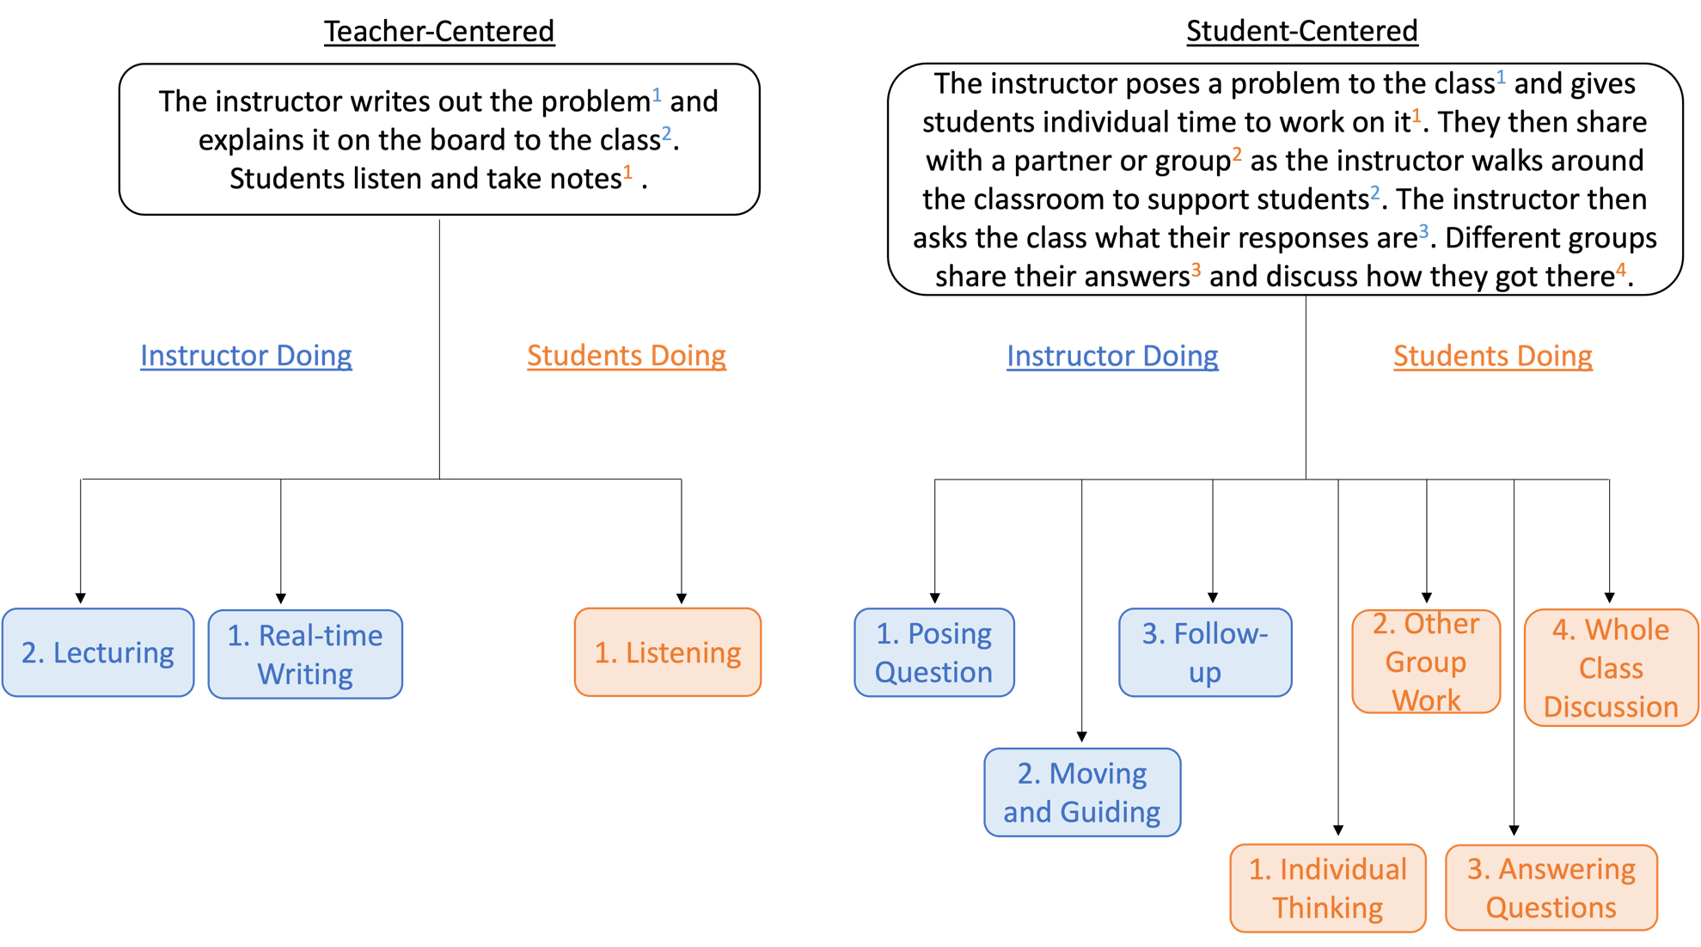

- How do I shift from a Presenting to a Guiding codes?
The following pie charts with COPUS results illustrate two examples of instructor behaviors.

This bar graph is an example of a teacher-centered class session, illustrating mainly Presenting teaching practices (Lecturing, Real-time Writing). | This bar graph is an example of a student-centered class session illustrating majority of Guiding teaching practices (Follow-up, Posing Questions, Clicker Question, Answering Question, Moving and Guiding, One-on-One).

While there is not a guaranteed combination of COPUS codes that will ensure student learning, studies suggest that active learning activities encourage student engagement (Aji & Khan, 2019). To move the teacher-centered instructor towards student-centered practices, the instructor can incorporate more Guiding practices. For example, instead of just Lecturing (Lec) and Real-time Writing (RtW), they can ask students a question to discuss the question in groups. This gives the instructor an opportunity to walk throughout the classroom during student discussion (MG), spend one-on-one time with students (1o1), and follow-up (FUp) with a class discussion (WC) after groups decide on the answer.
Refer to our CDOP handout to learn more about interactive student-student questioning examples during whole class discussions or one-on-one time.

- How do I shift students’ codes from Receiving to Working and Talking?
The following COPUS results illustrate two examples of student behaviors, which correlate with the instructor behaviors above.

This pie chart is an example of the student behaviors in a teacher-centered instruction, illustrating mainly Receiving practices (Listening). | This pie chart is an example of the student behaviors of a student-centered instructor, illustrating mainly Working and Talking practices (Individual thinking, Other group activity, Answering Questions, Asking Questions, Whole class Discussions.

The student-centered classroom offers many opportunities for students to be involved in the class session, such as discussing with their peers, individually answering questions, and participating in whole class discussions. Again, incorporating these activities is not a guarantee that students will become more engaged in the class session, but rather provide them a chance to do so. To move a teacher-centered instructor toward student-centered practices, we recommend incorporating more codes from the Working and Talking category. For example, instead of studentsl listening to the instructor for the entire class period, instructors could create opportunities for students to have discussions (WC), ask and answer questions (AnQ, SQ), and share their ideas with their peers (OG, CG, WG).

- How do I introduce more codes in the Guiding and Working and Talking Category
Below are some classroom activities we have observed in classrooms paired with the possible COPUS codes that could go with it.

Activity | Instructor COPUS Code | Student COPUS Code
Think-Pair-Share | 1. Posing Question (PQ) | 1.Individual Thinking (Ind)  2.Other Group Work (OG)  3.Whole Class Discussion (WC)  4.Answering Question (AnQ)  5.Student Question (SQ)
Clicker Question | 1. Clicker Question (CQ)  2. Follow-up (FUp) | 1.Individual Thinking (Ind)  2.Group Clicker Question (CG)  3.Whole Class Discussion (WC)  4.Answering Question (AnQ)  5.Student Question (SQ)
Exit Ticket | 1. Posing Question (PQ) | 1.Individual Thinking (Ind)
Student Presentation | 1. Follow-up (FUp) | 1. Student Presentation (SP)  2. Listening (L)  3. Whole Class Discussion (WC)  4. Answering Question (AnQ)  5. Student Question (SQ)

The key to remembering and succeeding at building a habit is to focus on adding just one code at a time and practice it; choose one activity you are currently doing from Figure 1, anchor a new one code to that activity, and repeat until it becomes a habit, like driving or brushing your teeth. Once it becomes a habit, incorporate another code and repeat the process to build stackable habits and, thus, expand your COPUS codes and active learning implementation in your classroom.

References
- Aji, C. A., & Khan, M. J. (2019). The impact of active learning on students’ academic performance. Open Journal of Social Sciences, 7(03).
- Active learning. Active Learning - Eberly Center - Carnegie Mellon University. (n.d.). Retrieved January 26, 2022, from https://www.cmu.edu/teaching/designteach/diversityequityinclusion/activelearning/index.html
- Edith Cowan University, Perth, Western Australia. (2016, October 20). Student presentations. ECU Intranet. Retrieved January 26, 2022, from https://intranet.ecu.edu.au/learning/curriculum-design/teaching-strategies/student-presentations
- Exit ticket. The Teacher Toolkit. (n.d.). Retrieved January 26, 2022, from https://www.theteachertoolkit.com/index.php/tool/exit-ticket
- Kranzfelder, P., Bankers-Fulbright, J. L., García-Ojeda, M. E., Melloy, M., Mohammed, S., & Warfa, A. R. M. (2019). The Classroom Discourse Observation Protocol (CDOP): A quantitative method for characterizing teacher discourse moves in undergraduate STEM learning environments. PloS one, 14(7), e0219019.
- Smith, M. K., Vinson, E. L., Smith, J. A., Lewin, J. D., & Stetzer, M. R. (2014). A campus-wide study of STEM courses: New perspectives on teaching practices and perceptions. CBE—Life Sciences Education, 13(4), 624-635.
- Smith, M. K., Jones, F. H., Gilbert, S. L., & Wieman, C. E. (2013). The Classroom Observation Protocol for Undergraduate STEM (COPUS): A new instrument to characterize university STEM classroom practices. CBE—Life Sciences Education, 12(4), 618-627.
- Teaching with Clickers . Teaching with Clickers - Eberly Center - Carnegie Mellon University. (n.d.). Retrieved January 26, 2022, from https://www.cmu.edu/teaching/clickers/

