Table of Contents
- Automating messages in CatCourses (Canvas)
  - Message students based on total grade
  - Message students based on a single assignment
- Template emails
  - Initial email after first notice
  - Email after a specific assignment or general class email
  - Mid-semester grade email to student in need of support and resources

Identify performance at the mid-semester point: How to Filter Students Based on Grades in Canvas

Message Students Based on Total Grade:
For detailed instructions on how to send messages to all students with a specific total grade through Canvas gradebook, see this article. Otherwise, follow these steps:
Step 1: Open your course homepage
Step 2: Select “New Analytics” on the right side.
Step 3: Select “Course Grade”, then filter to specific grade and send a message.
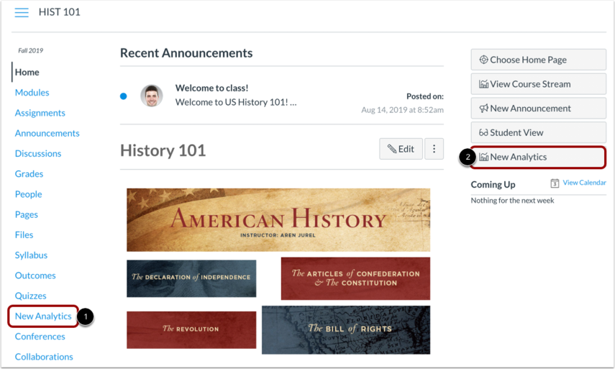

Message Students Based on Assignment Grade:
For detailed instructions on how to filter and send messages through Canvas gradebook, see this article. Otherwise, follow these steps:
Step 1: Open your CatCourses Gradebook
Step 2: Open assignment menu (three dots on the top right)
Step 3: Select “Message students who...” and select the “Scored less than” category.
Step 4: Copy the template emails provided here, edit as needed, and send away!
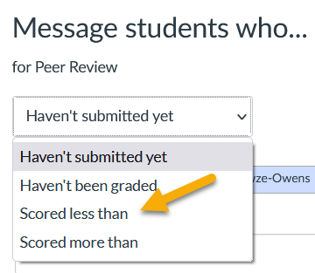

Email Templates for Interventions
The following templates provide suggested language that might be used to contact students who have been identified as needing additional support. Instructors are free to adopt the sample emails or modify them as needed.

First Point of Contact After the First /Early Assessment (TA in large courses and IOR in small courses)

Background and Rationale:
To focus the discussion on growth and learning, the initial communication can be casual and personalized. Consider discussing a specific example or a general behavioral pattern noticed with this student. In large classes, leverage the interaction the students have with the TAs as a point of contact that is less intimidating. This email is highly effective in showing students their instructors care about their learning and, in most cases, will inspire action.

EMAIL SUBJECT: Checking In

Hello __________,

I noticed you _____________ (e.g., didn’t turn in your homework, missed discussion, did not perform your best on your quiz, etc.) and want to check in on you. How is everything going? I want to give you an opportunity to succeed. Please let me know how I can best support you.

Let’s connect soon.
___________

After the First Assessment OR After TA Notification of Student in Need

Background and Rationale:
If the student does not reply or act in response to initial communications or this is a general communication going out to a larger number of students early in the semester, consider language that is focused on what the student(s) can do to focus on the learning process. This communication can also be sent to all students so everyone understands the process and can take some time reflect on their learning. What are the steps they can take to make progress? What resources are available to them?

In essence, students must develop into self-regulated learners who set personal goals, select strategies that help them achieve those goals, implement those strategies, and monitor progress (Shunk, 1996). Research reveals that few students are fully self-regulated when they enter college; however, those with better self-regulation skills generally learn more with less effort and report higher levels of academic satisfaction (Schraw, Crippen, & Hartly, 2006).

EMAIL SUBJECT: Self-Assess Your Learning Now: “Stop, Start, Continue”

Dear Students,

This week we had our first ___________ (e.g., quiz, homework, writing assignment, something with feedback or grade). These low-stakes, formative assessments provide you with an opportunity to 1) monitor your learning progress throughout the course and 2) adjust how you study and prepare for these assessments while it is still early in the semester.

Success in school depends on the ability to plan, organize materials, manage time, and execute plans. Our goal here is to help you become self-regulated learners. This skill is essential not only for your success in college but also in your career.

Consider the following reflection on your learning process today: What is not supporting your learning that you would like to stop doing? What would you like to start doing to support your learning? What is working that would like to continue?

In addition, success in any course depends on your ability to use information and feedback provided by the instructional team, as well as additional out-of-class resources to modify your academic behaviors. Consider taking advantage of the following resources:
- Office Hours/1-1 Meeting with Instructor or TA
- Content/Course-Based Intervention (e.g., supplementary activity, reflection assignment, etc.)
- Calvin Bright Success Center Learning Workshops
- Tutoring Services

Sincerely,

_____________

At Mid-Semester Grade –– Piping Students to Success

Background and Rationale:
At the halfway point in the semester, students who remain in the early stages of learning need specific actions to help them meet their learning goals. UC Merced has a clear path designated for students who need support at this stage. Instructors should use this communication to point students towards these pipelines. It important to emphasize a tone of genuine care and concern for the student, which often is an intervention on its own (Reynolds et al., 2009; Winfield 2018).

EMAIL SUBJECT: Mid-Semester Grades and Support

Dear __________,

We are halfway through the semester. This is an important time to take an honest assessment of your learning progress and implement techniques to make progress in the course. Midterm grades are an opportunity for us to navigate through your learning together, and to act where needed. After reviewing your progress, you are not where you should be at this point in the semester. I want to help you by offering you support and resources.

UC Merced has programs in place to help your academic success. Please take advantage of the Student Support for Mid-Term Grades. This program is designed to help students 1) identify challenges, 2) access curated resources, 3) build S.M.A.R.T. goals, and 4) recognize campus policies and expectations.

Let me know how else I can help you meet your learning goals. Please let me know how you are doing and how these opportunities have helped. I am looking forward to making progress together.

Sincerely,

______________

Want more information? Consider designing your class for student success, and implement some evidence-based prevention strategies to create early alert systems.

References:
- Reynolds, Amy L., John A. Mueller, and Marcia Roe Clark. (2009). Helping college students: Developing essential support skills for student affairs practice. San Francisco, CA: Jossey-Bass.
- Schunk, D. (1996). Goal and self-evaluative influences during children’s cognitive skill learning. American Educational Research Journal, 33(2), 359–382.
- Schraw, G., Crippen, K.J., & Hartley, K. (2006). Promoting Self-Regulation in Science Education: Metacognition as Part of a Broader Perspective on Learning. Research in Science Education, 36: 111–139. DOI: 10.1007/s11165-005-3917-8
- Winfield, J.K. (2018). The Art of Intervention: Partnering with Faculty for Early Academic Alert. Academic Advising Today: 41(4). Retrieved at https://nacada.ksu.edu/Resources/Academic-Advising-Today/View-Articles/The-Art-of-Intervention-Partnering-with-Faculty-for-Early-Academic-Alert.aspx

