Writing Clear Learning Outcomes and Lesson Objectives

A goal is a broad statement that represents the overall impact you would like to achieve through your program/course. The desired outcome and more specific lesson objectives are a way to make goals more specific and attainable.

Learning Objectives for a lesson (attached to a course learning outcome)
- are specific, measurable, and attainable statements that let you know when students have reached
Your lesson objectives
- describe specific changes in knowledge, attitudes, skills, and/or behaviors you expect as a result of your planned instructional experiences.

When analyzing and/or writing objectives statements, it can be useful to think about the ABCD structure (Audience, Behavior, Conditions, Degree (of Performance).

Audience: The student is the audience (The student will (TSW)....)
Behavior: The action student will take to demonstrate understanding/mastery (e.g., create, analyze)
Condition: Note any special conditions of the performance (e.g., Given a set of data; using Python)
Degree: Any specific level of performance desired (e.g., a minimum of three examples;
**condition is optional

Sample Goal, Outcome and Objective Statement:
Course Goal | To develop as a scholar in the discipline.
Course Outcome | Develop a research paper, including a complete literature review, and write in the style of the discipline.
Course Objective | Given a selected research topic, TSW present findings and cite at least 12 research sources according to the guidelines in Chicago Style Manual, 11th edition or later.  Audience: TSW  Behavior: present findings and cite research sources  Conditions: Given a selected research topic  Degree: at least 12...using Chicago Style Manual...

Outcomes Activity
With the current syllabus, list and analyze the learning outcomes for your course. Simply answer “Yes” or no in each column. If you answer “no” in any column, this indicates an opportunity to rephrase and clarify the outcomes so that it meets all three criteria for a well-stated outcome.

CLO | Specific | Measurable | Attainable
CLO 1

CLO 2

CLO 3

CLO 4

CLO 5

CLO 6

CLO 1:
Write at least one learning objective using the ABCD model.

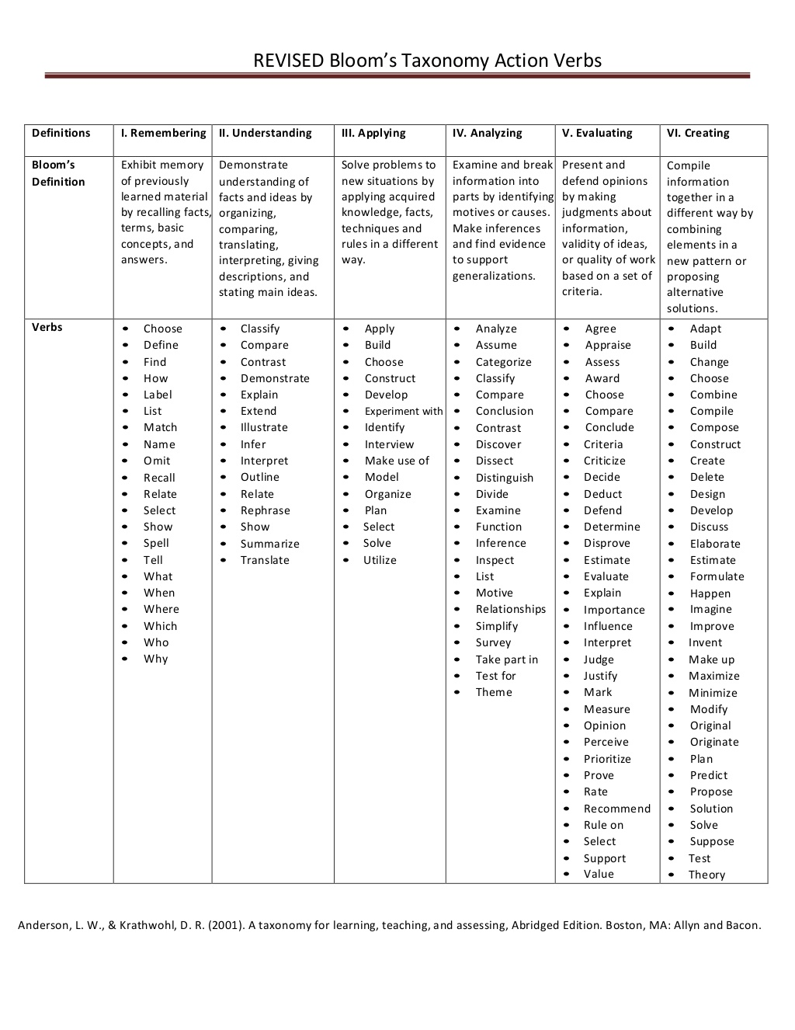
Bloom’s Taxonomy of Verbs

